

**OUTREACH SCHOOLS EXAMINATIONS BOARD**

**BEGINNING OF TERM III EXAMINATION 2024**

**P.5 INTEGRATED SCIENCE**

***Time Allowed: 2hours 15 Minutes***

**Pupil’s Name: ……………………………………..……………………**

**Class: ………………………………………………………………………**

**School Name: ………………………………………………………….**

|  |  |  |
| --- | --- | --- |
| **FOR EXAMINERS’**  USE ONLY | | |
| **Qn. No.** | **MARKS** | **EXR’S**  **No.** |
| **1 - 10** |  |  |
| **11 – 20** |  |  |
| **21 – 30** |  |  |
| **31 – 40** |  |  |
| **41 – 43** |  |  |
| **44 – 46** |  |  |
| **47 – 49** |  |  |
| **50 - 52** |  |  |
| **53 - 55** |  |  |
| **TOTAL** |  |  |

**Read the following instructions carefully:**

1. This paper has two sections: **A** and **B**
2. Section **A** has 40 questions (40 marks)
3. Section **B** has 15 questions (50 marks)
4. Answer all questions. All the working for both sections A and B must be shown in the spaces provided.
5. All working must be done using a blue or black ball point pen or ink. Any work done in pencil will NOT be marked except drawings and diagram.
6. Unnecessary changes in your work and handwriting that cannot be easily read may lead to loss of marks.
7. Do not fill anything in the table indicated

**“For examiners’ use only”** and the boxes inside the question paper.

***Turn Over***

**SECTION A**

1. Name one example of a stem tuber.

______________________________________________________________________

1. Give any one method by which plants with weak stems climb others.

______________________________________________________________________

1. Mention one effect of heat on matter.

______________________________________________________________________

1. What causes malaria?

______________________________________________________________________

1. Give one condition necessary for seed germination?

______________________________________________________________________

1. How is a pest different from a **vector**?

______________________________________________________________________

1. State one characteristic of wind pollinated flowers.

______________________________________________________________________

1. State one activity done to promote oral hygiene.

______________________________________________________________________

1. Name one plant that grows in dry areas.

______________________________________________________________________

**The diagram below shows a maize grain use it to answer questions 10 and 11.**

1. 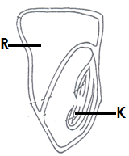Name part marked **R**. _________________________________________________
2. Why is the maize grain referred to as a fruit?

__________________________________________________________________________________________________

1. Give one way in which moving air is useful in the environment.

______________________________________________________________________

1. Identify one example of an organic manure.

______________________________________________________________________

1. In Which way are gills of a fish similar to spiracles of an insect?

______________________________________________________________________

1. How do toadstools reproduce?

______________________________________________________________________

1. Name the juice produced by the stomach.

______________________________________________________________________

1. In which state of matter does heat travel by conduction?

______________________________________________________________________

1. Mention one stage of development of a butterfly which is dormant (inactive)

______________________________________________________________________

1. Which quantity of water is needed for preparing Oral Rehydration Solution?

______________________________________________________________________

1. How does mulching control soil erosion?

______________________________________________________________________

1. Give the function of the tooth shown below.

______________________________________________________________

1. The **mass** of a bag of rice is **60g**. If its volume is **10cc**. calculate the **density** of the bag.
2. Identify any one physical difference between a cock and a hen?

______________________________________________________________________

1. State one factor a farmer should consider when starting a farm.

______________________________________________________________________

1. How is the process of transpiration important to plants?

______________________________________________________________________

1. Why are people advised to wash fruits and vegetables before eating them?

______________________________________________________________________

1. Which gas is needed for photosynthesis?

______________________________________________________________________

1. How does painting prevent metals from rusting?

______________________________________________________________________

1. In the space below, draw a leaf with parallel leaf venation.
2. Give one example of an aquatic animal.

______________________________________________________________________

1. Why are seeds of some plants first planted in the nursery bed before being taken to the main garden?

______________________________________________________________________

1. Mention one local method of preserving food.

______________________________________________________________________

1. What collective name is given to a set of equipment used for giving First Aid?

______________________________________________________________________

1. Mr. Okello mixed water and salt. What advice can you give him to recover the salt?

______________________________________________________________________

1. How is soil erosion controlled in the school compound?

______________________________________________________________________

1. Give one characteristic of exotic breeds of rabbits.

______________________________________________________________________

1. Identify the property of air shown in the diagram below.

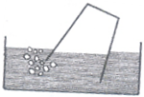

____________________________________________________

1. Give one example of a fowl vice.

______________________________________________________________________

1. Mention one way in which we should care for our beddings.

______________________________________________________________________

1. State one use of a queen excluder in a hive.

______________________________________________________________________

**SECTION B**

1. a) Explain the term **dehydration.**

______________________________________________________________________

______________________________________________________________________

b) Identify any one sign of a dehydrated person.

______________________________________________________________________

c) Which component of ORS provides energy to a dehydrated person?

______________________________________________________________________

d) Give one way of controlling dehydration.

______________________________________________________________________

1. Name the body organ which is used for;
2. pumping blood to all body parts

______________________________________________________________________

1. Exchange of gases in the human body.

______________________________________________________________________

1. Producing bile juice

______________________________________________________________________

1. Interpreting of messages

______________________________________________________________________

1. 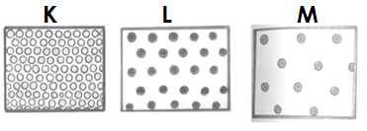**Use the illustration below to answer questions that follow.**
2. Name the states of matter labeled;

i)**K**________________________________(ii)**L** _______________________________

b) Suggest any one substance with molecular arrangement **M**.

______________________________________________________________________

1. In which state of matter does heat travel slowest?

______________________________________________________________________

1. a) What is **immunity**?

______________________________________________________________________

b) Write down the two types of immunity.

i) ____________________________________________________________________

ii)____________________________________________________________________

c) State one group of people who receive **TT** vaccine.

______________________________________________________________________

1. Man needs basic needs such as **shelter, food, clothes and medical care**.
2. Which of the basic needs above protects man from harsh weather?

______________________________________________________________________

1. Identify the basic need above that protects children from deficiency diseases.

______________________________________________________________________

1. Give two reasons why animals move from one place to another.

i) ____________________________________________________________________

ii)____________________________________________________________________

1. 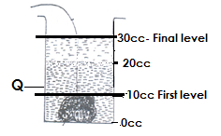**Study the diagram below and use it to answer questions that follow**
2. Name the container marked **Q.**

___________________________________________________________________

1. Find the volume of the irregular object.

______________________________________________________________________

1. What method of finding volume is shown above?

______________________________________________________________________

1. Why does a stone sink in water?

______________________________________________________________________

1. a) What are deficiency diseases? ______________________________________________________________________

______________________________________________________________________

1. Write the cause of each of the following deficiency diseases;

i) Scurvy ______________________________________________________________

ii) Kwashiorkor _________________________________________________________

iii) Anaemia____________________________________________________________

1. **Match the contents in List A with those in list B correctly.**

|  |  |
| --- | --- |
| **LIST A** | **LIST B** |
| Scald | Torn ligament |
| Sprain | Slight displacement of a bone from a joint. |
| Fracture | An injury caused by wet heat |
| Dislocation | A broken (cracked) bone |

1. Scald: ______________________________________________________
2. Sprain: _____________________________________________________
3. Fracture: ___________________________________________________
4. Dislocation: __________________________________________________
5. a) How does bacteria reproduce?

______________________________________________________________________

1. Write down two ways in which bacteria are useful to man.
2. ________________________________________________________________
3. ________________________________________________________________
4. Mention one bacterial disease that attacks people.

______________________________________________________________________

1. a) Write down the three classes of food.
2. ________________________________________________________________
3. ________________________________________________________________
4. ________________________________________________________________

b) Which class of food give energy?

______________________________________________________________________

1. a) What is poultry?

______________________________________________________________________

b) Why do farmers in rural areas prefer free range system to battery cage system?

______________________________________________________________________

c) Give two reasons why farmers keep.

i) ____________________________________________________________________

ii)____________________________________________________________________

**Use the diagram below to answer questions 52.**

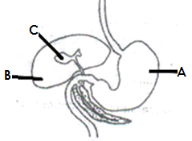

1. a) Name the parts marked **A** and **C**.

i) **A** _________________________________________________________________

ii) **C**__________________________________________________________________

b) Write two disorders of the digestive system.

i) ____________________________________________________________________

ii)____________________________________________________________________

1. a) How is the following types of bees important in a hive

i) The worker bee: _______________________________________________________

ii) The drone bee: _______________________________________________________

b) Give any two importance of bee keeping.

i) ____________________________________________________________________

ii)____________________________________________________________________

1. a) State the two conditions of weather.

i) ____________________________________________________________________

ii)____________________________________________________________________

b) Give the use of each of the following instruments

i) Barometer

______________________________________________________________________

ii) Wind sock

______________________________________________________________________

1. **The diagram below shows system of a legume. Study it carefully and use it to answer questions that follow.**

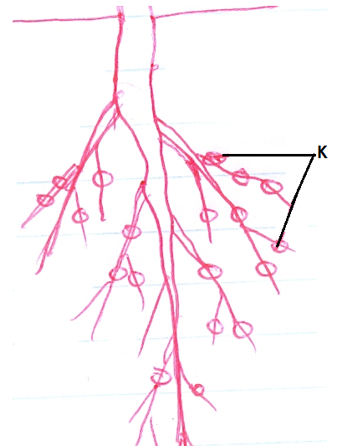

1. Name the living organisms found in structures marked **K**.

______________________________________________________________________

1. How is the living organisms you have named in (a) above useful?

______________________________________________________________________

1. Mention two examples of crops that bear structures marked K above on their roots.

i) ____________________________________________________________________

ii) ____________________________________________________________________

**END**